Dear Potential Optimist Club Business Member,

The Optimist Club of West Bend is excited to be able to offer a limited number of Business Memberships to businesses in the West Bend Area.

When considering how the Optimist Club of West Bend could continue to support its various youth-oriented projects, both now and into the future, one way identified is to broaden its membership to include local businesses. That is why the Optimist Club of West Bend has created the new category:

Business Buddy, an Optimist Club Business Membership

We know that running a business is time consuming and time is money. Having the time to get away to a meeting or an event can be a huge challenge. Our Business Membership is structured to allow any of your employees to attend a meeting or event with our club. This could be the same person, a rotation, whoever is interested or whoever is available. The best part, is that attendance is not required or even expected, but is always appreciated.

The Optimist Club of West Bend would like to invite your business to become a “Business Buddy” and join our efforts in “Bringing Out the Best in Kids.” We are offering you the opportunity to align your business with the many positive youth activities and awards supported by the Optimist Club of West Bend.

Please review the additional information in this folder which shows how the Optimist Club of West Bend fulfills its stated mission and purposes, and then consider how much positive public exposure your business would garner by being identified as an Optimist Club Business Member – “Business Buddy.”

Benefits of a Business Membership

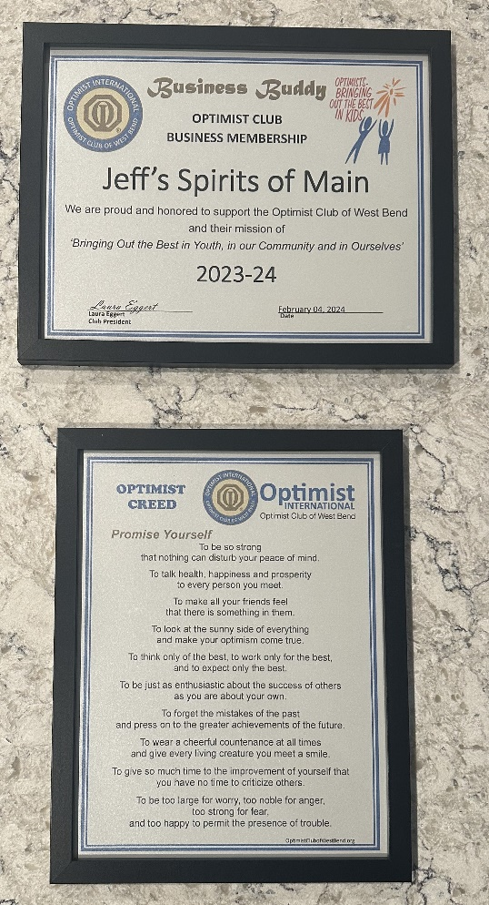
- Any employee, as a business representative, can attend a club meeting and have lunch.
- Any employee, as a business representative, can attend club events or functions.
- The business has equal voting rights for all club business.
- The business will receive the Optimist Magazine from Optimist International.
- The business will receive a framed certificate.
- The business will receive a framed Optimist Creed.
- The business will be advertised in the Club Newsletter and website (www.OptimistClubofWestBend).
- The business will receive the Club Newsletter.
- Attendees at meetings and events are covered by insurance provided through Optimist International.

Costs of a Business Membership

Term | Membership Period | Joining Timeframe | Cost
Full Year | October 1 – September 30 | Join Prior to October 1 – December 31 | $340
Partial Year (3/4) | January 1 – September 30 | Join Between January 1 – March 31 | $255
Partial Year (1/2) | April 1 – September 30 | Join Between April 1 – June 30 | $170
Partial Year (1/4) | July 1 – September 30 | Join Between July 1 – August 31 | $85

